Course Project cover page

S# | Student Name | Edu Email | Student ID | Marks
 |  |  |  | Report & Slides  (30) | Implementation  )50) | Presentation  (20) | Total  (100)
1 | عبدالرحمن غريب عبدالستار | abdelrahman.ghareb21@feng.bu.edu.eg | 221902911
2 | احمد حمدي عبدالستار | ahmed403176@feng.bu.edu.eg | 221903084
3 | عبدالعزيز احمد عبدالعزيز | abdulaziz414046@feng.bu.edu.eg | 221903195
4 | احمد عمرو احمد | ahmed403176@feng.bu.edu.eg | 231903714
5 | مهند محمود عبدالوهاب | mohannad414226@feng.bu.edu.eg | 221903201
6 | روان عبدالعزيز علي | rawan403225@feng.bu.edu.eg | 221903115

Date handed in: 3 / 5 / 2024

Database management Systems by
Binary Search tree
Introduction:
Binary Search Tree, or BST for short, is a very known and important data structure used in many different applications, it can be built using an array or a Linked list, and it is more complex data structure than a queue or a stack, and the BST is but one of the many types of Tree Data Structures.
In this report, we will tackle a simple implementation code, for it, using MIPS assembly language as the base, however, before we dive into the code of the structure; let’s first mention some applications of the BST.
Applications in Real Life:
- Database Systems:
Binary search trees are used in database indexing structures, facilitating quick search and retrieval of records based on key values.
- File Systems:
File systems utilize BSTs to maintain directory structures, enabling efficient storage and retrieval of files.
- Symbol Tables:
In programming languages and compilers, BSTs form the basis of symbol tables, which facilitate the quick and easy search for identifiers and the values that go with them.

- Networking:
Binary search trees are frequently used in network router routing tables to optimize routing choices.

- Dictionaries and Spell Checkers:
In dictionary implementations and spell checkers, binary search trees are used to store and retrieve words effectively, giving users instant access to definitions and suggestions for misspelled words.

- Automatic Indexing in Document Management Systems:
Binary search trees are used by document management systems to automatically index documents using keywords, allowing for the quick and precise retrieval of pertinent content.

- Genetic Algorithms and Evolutionary Computing:
In genetic algorithms and evolutionary computing, binary search trees are used to represent and optimize solution spaces, making it possible to explore and exploit potential solutions efficiently.

- Cryptography:
Binary search trees are used in cryptography to manage keys in cryptographic protocols and algorithms, making it easier to store and retrieve encryption keys securely.

- Natural Language Processing (NLP):
Binary search trees are used by NLP programs to store lexicons, parsing trees, and other linguistic data structures that help with tasks like text summarization, sentiment analysis, and language translation.
Now that some of its applications were mentioned, we will start with the implementation of the tree, splitting it into different sections:
- Data and user interface
- Adding a record
- Set Memory Locations
- Finding a record
- Tree Traversal
- Modifying a record

- Data and user interface:
In this section, the data and interface sections will be showcased, starting with the data code block:
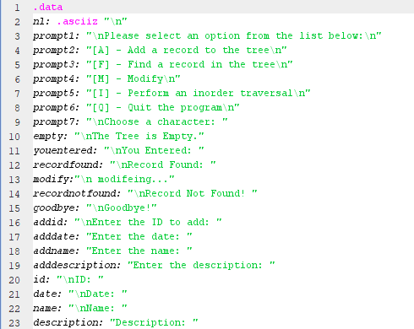

- Data:
N1: (. asciiz)” \n”
_ asciiz is breaking a long string into multiple string statements.
_ “\n” get a new line
_ N1 is the variable that is defined for the new line

prompt1: "\n Please select an option from the list below: \n"
this is the first message appears to the users that tells them to take action to start the program by selecting on of the options on the list, and we stored this message in a variable named “prompt1”

prompt2: "[A] - Add a record to the tree\n"
This is the first option on the list that tells the users if they want to add a record, they must press character [a], and this message is stored in a variable named “prompt2”.

prompt3: "[F] - Find a record in the tree\n"
This is the second option on the list that tells the users if they want to find a record stored before in the tree, they must press character[f], and this message is stored in a variable named “prompt3”.
prompt4: "[M] - Modify\n"
This is the third option on the list that allow user to modify records that is already saved, this message is stored in variable named “prompt4”
prompt5: "[I] - Perform an in-order traversal\n"
this is the fourth option on the list, that is used to perform the records ascendingly with respect to IDs, and this message is stored in variable named “prompt5”

prompt6: "[Q] - Quit the program\n"
This is the fifth option on the list, it tells the user if they want to quit the program press [Q], this message is stored in a variable names “prompt6”.
prompt7: "\nChoose a character: "
This is message for user to start choosing option from the list, the message stored in “prompt7”.
empty: "\nThe Tree is Empty."
This message appears when the user wants to find a record or modify when there are no records stored in the tree, this message is stored in a variable named “empty”.
youentered: "\nYou Entered: "
This message confirms to the user that they are in the system, and this message is stored in a variable named “youentered”.
recordfound: "\nRecord Found: "
This message appears when the user chooses option [f] and enters the ID to find the record, if the record is stored in the tree before, system will print this message and then the data of the record, this message is stored in a variable named “recordfound”.

recordnotfound: "\nRecord Not Found! "
This message appears when the user chooses option [f] and enters the ID to find the record. If the record is not stored in the tree before, the system will print this message, this message is stored in a variable named “recordnotfound”.
goodbye: "\nGoodbye!"
This message appears when the user chooses option [q] that quits the program, this message is stored in a variable named “goodbye”.
addid: "\nEnter the ID to add: "
This message appears when the user chooses option [a] that adds a record, the first step to add a record is to enter the ID.
User must write an integer number in the ID.
This message is stored in a variable named “addid”.
adddate: "Enter the date: "
This message appears when the user chooses option [a] and enter the ID, so the second step to add a record is to enter the date.
User must write an integer number in this step.
This message is stored in a variable named “adddate”.
addname: "Enter the name: "
This message appears after choosing option [a] and entering the ID and the date, so the third step to add a record is to add the name.
User at this step should enter a string.
This message is stored in a variable named “addname”.
adddescription: "Enter the description: "
This message appears after choosing option [a], entering the ID, date, and name, so the fourth step to add a record is to add a description and it must be string input.
This message is stored in a variable named “adddescription”.
id: "\nID: "
This message appears when the user chooses option [f] to find a record.
The first and only step is to enter the ID of the record, so this message tells you to enter the ID.
This message is stored in a variable named “id”.
date: "\n Date: "
this message appears after choosing option [f] and entering the ID.
User has no work with this step.
The system uses this message as a title to display the date of the founded record after it.
This message is stored in a variable named “date”.
name: "\n Name: "
this message appears in parallel with the date message after choosing option [f] to find the record.
System uses this message as a title to display the name of the founded record after it.
This message is stored in a variable named “name”.

description: "Description: "
This message appears in parallel with the year and title messages after choosing option [f] to find the record.
The system uses this message as a title to display the description of the founded record after it.
This message is stored in a variable named “description”.

- Prompt:

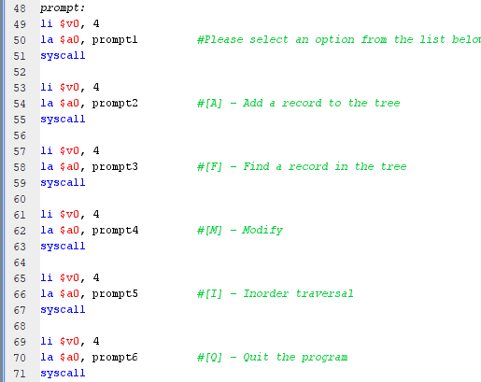

Prompt:
At this function we used $v0 = 4 to print all the messages and the list options to help the user to interact with the program.
Examples:
li $v0, 4
la $a0, prompt1
it prints “Please select an option from the list below:”, and by changing the value of $a0 to different variable names that we defined at data part, message will change.
getinput:
li $v0, 4
la $a0, prompt7
li $v0, 12
at this section we start with printing a message to get the input from user then taking the input by $v0 = 12 that takes a single character.
li $v0, 4
la $a0, n1
at this section we limit the user input as if the user entered something different from single character it will display a new line and then jump to the beginning of the functions that tells to enter a single character.
addrecord:
at this section we print messages and taking the data from the user to create a record.
li $v0, 4
la $a0, addid
This is for displaying the message by $v0 = 4 that print a string we used it also for add date, add name, and add description.
li $v0, 5
We used it for taking the date and id from the user, as they are the only inputs with integer values.
li $v0, 8
We used it for taking the name and description from the user, as they are the inputs with string values.
findrecord:
at this section we print the values if the record is found and print messages if the record is not found or if the tree is empty.
li $v0, 4
la $a0, empty
This is message if tree is empty, we change the $a0 value to display the message of record found or not.
li $v0, 4
la $a0, id
li $v0, 5
This is for displaying a message to the user that we need the id number to find the record, so $v0 equals 4 and 5 for message and the integer input respectively.
If record is found then we need to print the data of the record.
li $v0, 4
la $a0, id
li $v0, 1
this section to print “ID: “and the value of id.
we used the same way to print date, $v0 = 1 to print integer
By changing the value $v0 from 1 to 4 we printed the name and description stored values of that record.

inorder:
This section is not different from the previous part as we use the same technique to display (id, date, name, description) and the value of them from storage.

Modify:
This part is mixed with add and find records as we display message to get the id then we display (add date, add name, add description) messages and then modify by taking user inputs in date, name and description and of course printing message if tree is empty or record is not found.
exit:
li $v0, 4
la $a0, goodbye
we print string message to say goodbye that is why $v0 = 4.
li $v0, 10
this value of $v0 is to terminate the program.
- Adding a record:
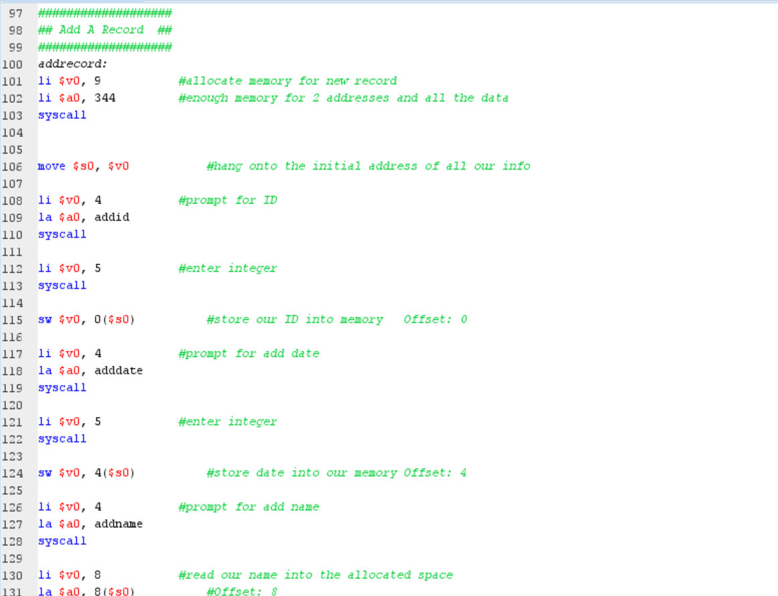
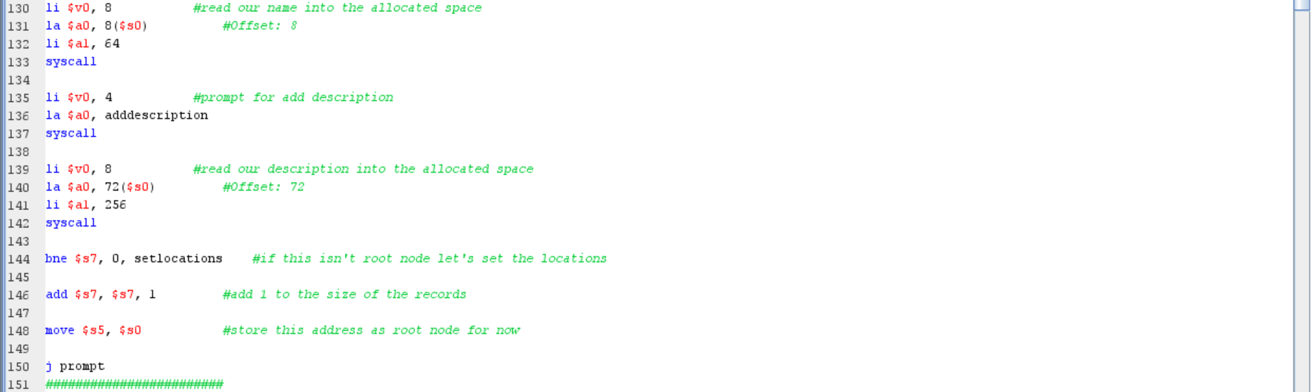
- Allocate Memory for New Record:
- The code starts by allocating memory for a new record using a system called syscall with service number 9.
- Registers $v0 and $a0 are used for system calls, where $v0 typically holds the system call number, and $a0 holds the arguments.
- In this case, $a0 is loaded with the amount of memory needed for the record.

- Prompt for ID and Store:
- The program prompts the user for an ID and stores it in the allocated memory.
- System calls are used again: syscall with service number 4 for output and 5 for input.
- After taking input, the ID is stored in memory at offset 0 from the initial address (($s0().

- Prompt for Add Date and Store:
- Similar to the ID, the program prompts for an add date and stores it in memory at offset 4 from the initial address.

- Prompt for Add Name and Store:
- Prompt the user for a name and store it in memory. This time, the name is read into the allocated space directly, using system call 8 (read string).

- Prompt for Add Description and Store:
- Same as the name prompt, but for a description. Again, the description is read into the allocated space.

- Set Locations (Optional):
- This section seems conditional, based on the value of register $s7. If it's not zero (indicating this isn't the root node), it sets the locations. Otherwise, it increments the size of records and stores the current address as the root node.

- Jump to Prompt:
- Finally, the program jumps back to a label called prompt, presumably to continue with further user interaction or operations.

- Set Memory Locations:
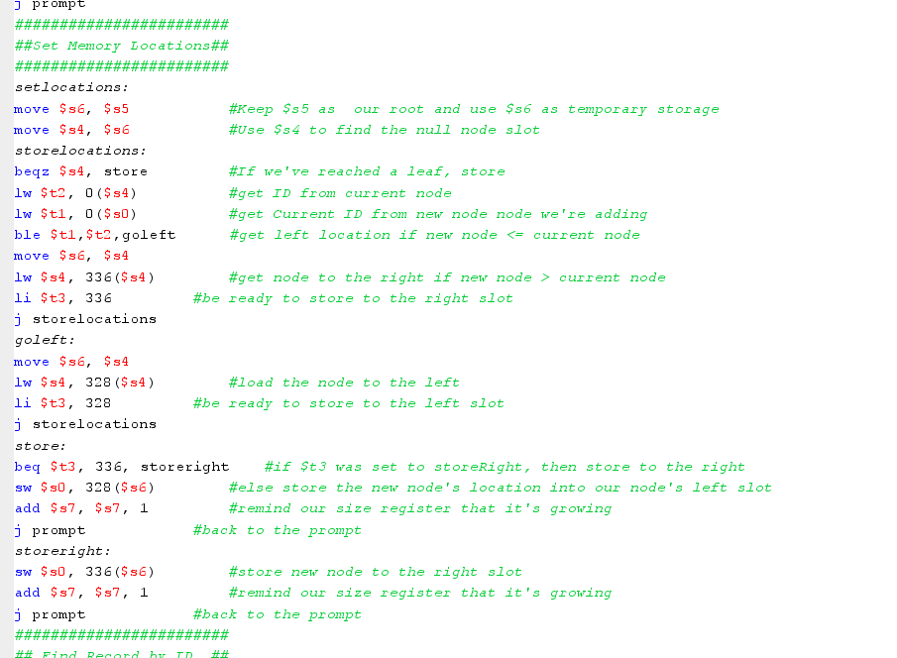
- setlocations:
  - setlocations: This appears to a function name.
  - move $s6, $s5: This line of code moves the value stored in register $s5 to register $s6.
  - move $s4, $s6: Similarly, this line moves the value from $s6 to $s4.

- storelocations:
- beqz $s4, store: This instruction checks if the value in register $s4is zero (i.e., if we've reached a leaf node). If it is, the program jumps to the (store) label.
- lw $t2, 0($s4): This loads the value from memory at the address pointed to by $s4 into temporary register $t2. It seems to retrieve an ID from the current node.
- lw $t1, 0($s0): Similarly, this loads the value from memory at the address pointed to by $s0 (which likely represents a new node) into temporary register $t1. It retrieves the current ID from the new node we're adding.
- ble $t1, $t2, goleft: The 'ble' (branch if less than or equal) instruction compares the values in $t1 and $t2. If the new node's ID is less than or equal to the current node's ID, the program jumps to the (goleft) label.
- move $s6, $s4: This line moves the value stored in register $s4 to register $s6. It's used as temporary storage.
- lw $s4, 336($s4): If the new node's ID is greater than the current node's ID, this instruction loads the value from memory at the address 336 bytes ahead of the current node's address (presumably the right child node).
- li $t3, 336: This sets the immediate value 336 into register ($t3(, indicating that we're ready to store to the right slot.
- (j storelocations): The program jumps to the (storelocations) label.
- goleft:
- If the new node's ID is less than the current node's ID, the program jumps here. The following instructions are like the previous case but for the left child node.
- store:
- This label is reached when we need to store the new node. If $t3 was set to 336 (indicating the right slot), it stores the new node to the right. Otherwise, it stores the new node to the left.
- storeright:
- If $t3 was set to 336, this label is reached, and the new node is stored to the right.

- Finally, both branches increment the size register ($s7) and jump back to the prompt.
- Finding a Record:
This section’s code main concern is finding checking if the record with the given ID is found in the tree. If found, it prints the record's details such as ID, date, name, and description. If the record is not found, it displays an error message that it is not found. The code handles cases where the record may not be found in the left or right sub-tree as well. It also handles the case if a tree is empty or not.
So we will split this section in two parts:
1) Finding the Record itself, and all its cases.
2) Printing the record when found.
1) Finding the Record Needed:
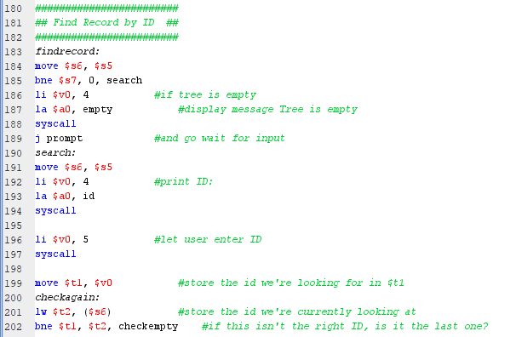

So, it will be explained in detail how this section of the code works:
- findrecord: just a label that indicates the start of a code section
- move $s6, $5: The value of register $s5 is copied to register $s6 by this instruction. It is usually used to store a register's current value for subsequent usage.
- bne $s7, 0, search: This branch instruction determines whether or not the value in register $s7 is less than or equal to zero. The code block labeled "search" will be jumped to if the condition is true, branching to the search label.
- li $v0, 4: In register $v0, the instantaneous value 4 is now loaded. $v0 is frequently used in MIPS to store the system call number.
- la $a0, empty: In register $v0, the instantaneous value 4 is now loaded. $v0 is frequently used in MIPS to store the system call number.
- syscall: Operating system operations are carried out through system calls, which are started by this command. In this instance, the string kept in $a0 will probably be printed.
- j prompt: This leap instruction is unqualified. It leaps to the prompt label, indicating that it will carry on executing from there.
- search: This label serves as a starting point for the search code block.
- move $s6, $s5: This duplicates the value from register $s5 to $s6, just like the move instruction from earlier.
- li $v0, 4: Loads the immediate value 4 into register $v0.
- la $a0, id: loads the string "ID"'s address into register $a0. This text most likely indicates that an ID must be entered.
- syscall: Triggers a system call to print the string stored in $a0.
- li $v0, 5: loads the value of 5 immediately into register $v0. The system call number for reading an integer from the user is represented by this value.
- syscall: carries out the system call to get the user's integer. Register $v0 will hold the value that was entered.
- move $t1, $v0: copies the value from $v0, the user-inputted ID, to register $t1.
- checkagain: another label indicating the start of the “checkagain” code block.
- lw $t2, ($s6): loads the word (4 bytes) of data into register $t2 from the memory address kept in register $s6.
- bne $t1, $t2, checkempty: If the values in registers $t1 and $t2 differ, branches to the label checkempty. It determines whether the ID being looked for is the current one. The checkempty code section will be tackled in the next part.
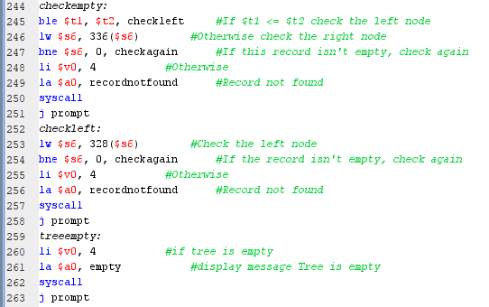
This is the “checkempty” code block, which will be discussed next.

- ble $t1, $t2, checkleft: If the value in register $t1 is less than or equal to (ble) the value in register $t2, then branches to the checkleft label.
- lw $s6, 336($s6): loads and saves a word (4 bytes) of data in register $s6 from the memory address determined by multiplying its value by 336.
- bne $s6, 0, checkagain: If the value in register $s6 is not equal (bne) to zero, branches to the checkagain label, basically checking if the current record is empty or not.
- li $v0, 4: Loads the immediate value 4 into register $v0.
- la $a0, recordnotfound: loads the string "recordnotfound"'s address into register $a0. This string is an indication that the record could not be located.
- syscall: Triggers a system call to print the string stored in $a0.
- j prompt: same as all the other “j prompt”s.
- checkleft: start of the checkleft code block
- lw $s6, 328($s6): loads and saves a word (4 bytes) of data in register $s6 from the memory address determined by multiplying its value by 328.
- bne $s6, 0, checkagain: If the value in register $s6 is not equal (bne) to zero, branches to the checkagain label. This check establishes whether or not the current record is empty.
- li $v0, 4: Loads the immediate value 4 into register $v0.
- la $a0, recordnotfound: loads the string "recordnotfound"'s address into register $a0. This string is an indication that the record could not be located.
- treeempty: enter the last block in this section, and one being mentioned before, the code block for when the tree is empty.
- li $v0, 4: Loads the immediate value 4 into register $v0.
- la $a0, empty: loads the string "empty" address into register $a0. The message that this string conveys is that the tree is empty.
- syscall: Triggers a system call to print the string stored in $a0.
- j prompt: jump to prompt.
This is the end of the “Find the record” Section, next will be:

2) Printing the record when found:
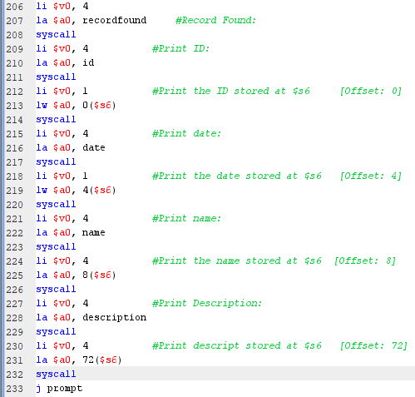
So, let’s start breaking down this final section:
- li $v0, 4: Loads the immediate value 4 into register $v0.
- la $a0, recordfound: loads the string "recordfound"'s address into register $a0.
- syscall: Triggers a system call to print the string stored in $a0.
- li $v0, 4: Loads the immediate value 4 into register $v0.
- la $a0, id: Loads the address of the string "id" into register $a0. This represents a prompt to print the ID.
- Syscall: Executes the system call to print the string stored in $a0.
- li $v0, 1: Loads the immediate value 1 into register $v0. This value represents the system call number for printing an integer.
- lw $a0, 0($s6): Loads the word (4 bytes) of data from the memory address stored in register $s6 (which likely points to the ID) and stores it in register $a0.
- syscall: Executes the system call to print the integer stored in $a0.
- li $v0, 4: Loads the immediate value 4 into register $v0.
- la $a0, date: Loads the address of the string "date" into register $a0. This represents a prompt to print the date.
- syscall: Executes the system call to print the string stored in $a0.
- li $v0, 1: Loads the immediate value 1 into register $v0.
- lw $a0, 4($s6): Loads the word (4 bytes) of data from the memory address stored in register $s6 (which likely points to the date) and stores it in register $a0.
- syscall: Executes the system call to print the integer stored in $a0.
- li $v0, 4: Loads the immediate value 4 into register $v0.
- la $a0, name: Loads the address of the string "name" into register $a0. This represents a prompt to print the name.
- syscall: Executes the system call to print the string stored in $a0.
- li $v0, 4: Loads the immediate value 4 into register $v0.
- la $a0, 8($s6): Loads the address of the string stored at offset 8 (likely the name) from the memory address stored in register $s6 and stores it in register $a0.
- syscall: Executes the system call to print the string stored in $a0.
- li $v0, 4: Loads the immediate value 4 into register $v0.
- la $a0, description: Loads the address of the string "description" into register $a0. This represents a prompt to print the description.
- syscall: Executes the system call to print the string stored in $a0.
- li $v0, 4: Loads the immediate value 4 into register $v0.
- la $a0, 72($s6): Loads the address of the string stored at offset 72 (likely the description) from the memory address stored in register $s6 and stores it in register $a0.
- syscall: Executes the system call to print the string stored in $a0.
- j prompt: Unconditionally jumps to the prompt label, which means it will continue execution from that point.
This section has a lot of similar or repeated code, but its necessary since the process of displaying the info is very similar.

Finally, we will make a quick summary of how the code as a whole work:
- The process starts at the beginning of the code block, assuming that the tree is not empty.

- The code block begins with a label checkempty. This label is used to handle the case when the current record is empty.

- The code compares the ID of the current record with the target ID. If the current record ID is less than or equal to the target ID (ble $t1, $t2, checkleft), it branches to the checkleft code block. Otherwise, it continues to the next step.

- If the current record ID is greater than the target ID, it means that the desired record may be in the right subtree. The code updates the pointer to the right subtree by loading the appropriate memory address (lw $s6, 336($s6)).

- The code then checks if the pointer to the right subtree is not equal to zero (bne $s6, 0, checkagain). If the pointer is not zero, it means there is a subtree to explore. In this case, the code branches to the checkagain label to continue the search in the right subtree.

- If the pointer to the right subtree is zero, it means that the right subtree is empty. In this case, the code assumes that the record with the desired ID is not found and proceeds to display a "recordnotfound" message (li $v0, 4, la $a0, recordnotfound, syscall), then jumps to the prompt label to continue execution.

- If the current record ID is less than the target ID, it means that the desired record may be in the left subtree. The code updates the pointer to the left subtree by loading the appropriate memory address (lw $s6, 328($s6)).

- The code then checks if the pointer to the left subtree is not equal to zero (bne $s6, 0, checkagain). If the pointer is not zero, it means there is a subtree to explore. In this case, the code branches to the checkagain label to continue the search in the left subtree.

- If the pointer to the left subtree is zero, it means that the left subtree is empty. In this case, similar to the right subtree case, the code assumes that the record with the desired ID is not found and proceeds to display a "recordnotfound" message, then jumps to the prompt label.

- If the tree itself is empty, the code block begins at the label treeempty. In this case, the code assumes that the tree is empty and displays an "empty" message (li $v0, 4, la $a0, empty, syscall), then jumps to the prompt label.

To put it briefly, the code block searches a binary tree structure for a record with a specified ID. In order to decide whether to carry on searching in the left or right subtree or to display the proper messages in the event that the record cannot be located, or the tree is empty, it compares the IDs of the current record and the target ID.
- Tree Traversal:
There are three ways to traverse a tree:
- In Order
- Post Order
- Pre Order
In this tree implementation, we will be using the in order Traversal.
- Definition:
In order traversal is a method used to visit all the nodes in a binary tree, particularly in binary search trees (BSTs). In this traversal, nodes are visited in the following order:
- Visit the left subtree.
- Visit the root node.
- Visit the right subtree.

For a BST, in order traversal results in visiting nodes in sorted order. This property makes it useful for operations such as printing the elements of a BST in sorted order or searching for elements efficiently.

- Algorithm for in order Traversal of Binary Tree:
The algorithm for in order traversal is shown as follows:
Inorder(root):
Follow steps 2 to 4 until root! = NULL
Inorder (root -> left)
Write root -> data
Inorder (root -> right)
End loop
- Information about it:
In computer science, particularly in the realm of binary trees and binary search trees (BSTs), in order traversal is a fundamental concept. Here's some more detailed information about in order traversal:
- Recursive Nature: In order traversal is usually implemented recursively. The traversal starts from the root of the tree. At each node, it recursively traverses the left subtree, then visits the node itself, and finally recursively traverses the right subtree.

- Sorted Order: In a BST, in order traversal visits the nodes in sorted order. This property is crucial for various operations on BSTs, such as searching for elements, inserting elements while maintaining the BST property, and deleting elements.

- Left-Root-Right Pattern: The name "in order" comes from the order in which the nodes are visited: left subtree, root node, right subtree.

- Uses:
- Printing elements of a BST in sorted order.
- Checking if a binary tree is a BST by ensuring that in order traversal produces a sorted sequence.
- Finding the Kth smallest or largest element in a BST.
- Checking for the presence of a particular element in a BST.
- In general, whenever you need to visit nodes in a sorted order in a binary tree, in order traversal is your go-to method.

- Time Complexity: The time complexity of in order traversal is O(n), where n is the number of nodes in the tree. This is because in order traversal visits each node exactly once.

Overall, in order traversal is a powerful and versatile technique used in various tree-related algorithms and applications. Its simplicity, combined with its effectiveness in producing a sorted sequence of elements, makes it a fundamental tool in the toolbox of any computer scientist or programmer dealing with binary trees and BST.
- The way it works:
- The traversal will go from 1 to its left subtree i.e., 2, then from 2 to its left subtree root, i.e., 4. Now 4 has no left subtree, so it will be visited. It also does not have any right subtree. So no more traversal from 4

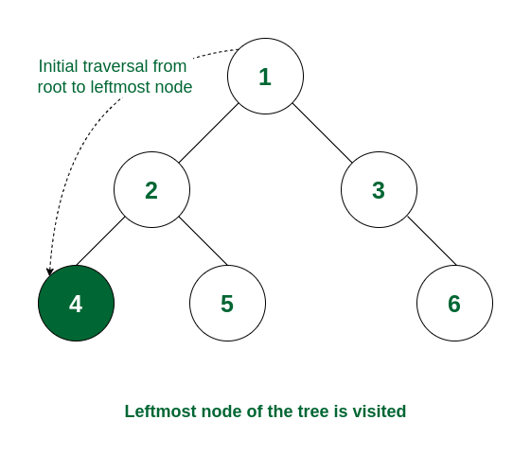
- As the left subtree of 2 is visited completely, now it read data of node 2 before moving to its right subtree.

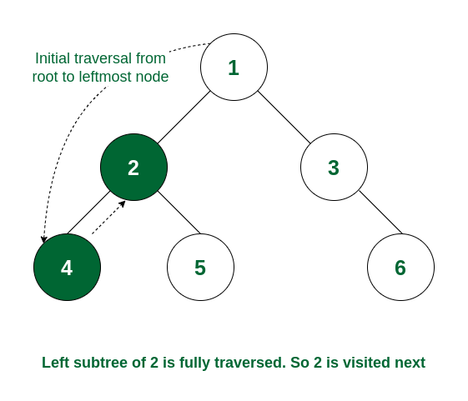

- Now the right subtree of 2 will be traversed i.e., move to node 5. For node 5 there is no left subtree, so it gets visited and after that, the traversal comes back because there is no right subtree of node 5.

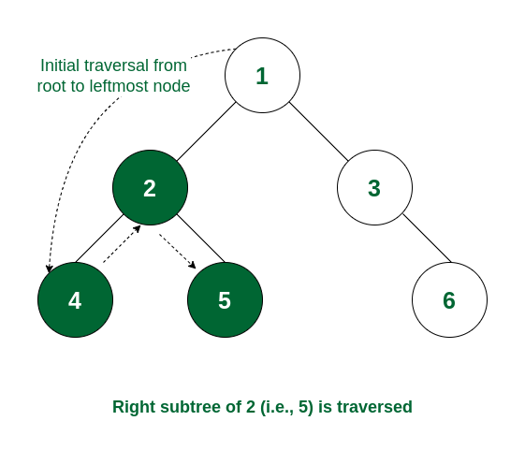

- As the left subtree of node 1 is, the root itself, i.e., node 1 will be visited.

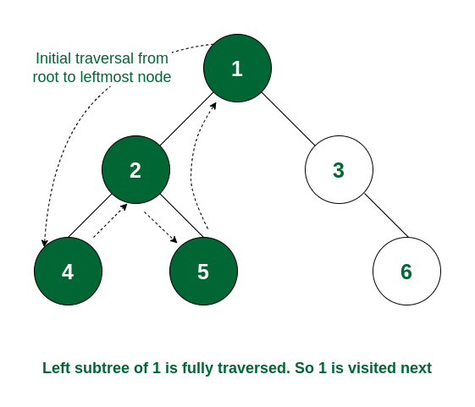

- Left subtree of node 1 and the node itself is visited. So now the right subtree of 1 will be traversed i.e., move to node 3. As node 3 has no left subtree so it gets visited.

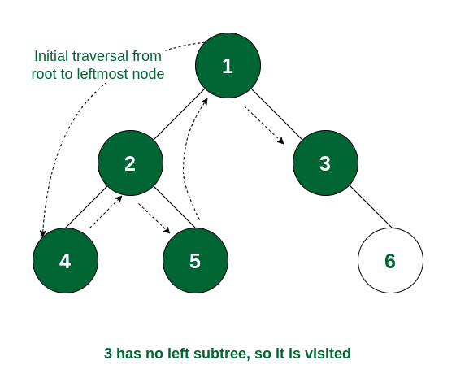

- The left subtree of node 3 and the node itself is visited. So traverse to the right subtree and visit node 6. Now the traversal ends as all the nodes are traversed.

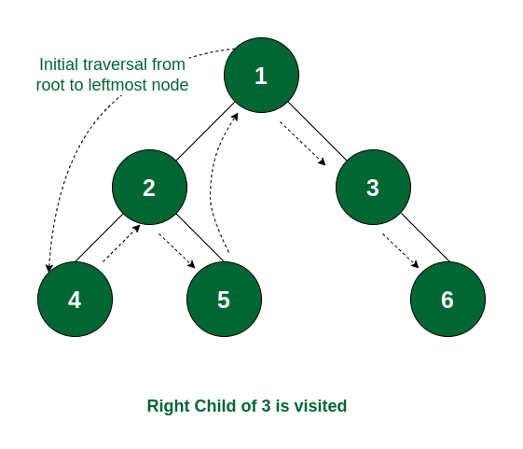

So, the order of traversal of nodes is 4 -> 2 -> 5 -> 1 -> 3 -> 6.

- Inorder in our MIPS code:
- Tree Empty Check (beq $s7, 0, treeempty):
- $s7 likely contains a pointer to the root of the tree. This instruction checks if this pointer is null, indicating an empty tree.
- If the tree is empty ($s7 is 0), the control transfers to the label treeempty, presumably to handle this special case.

- Initialization:
- $s6 is used to keep track of the current node being processed.
- $t0 is initialized with the address of the current node ($s6), which will be iterated to traverse the tree.
- $t1 is also initialized with the address of the current node ($s6). It's used to maintain the path taken during traversal, possibly to handle recursive calls.

- Print Inorder (jal printinorder):
- This subroutine is called to initiate the printing of the tree elements in inorder traversal.

- Printing Inorder (printinorder):
- This subroutine prints the tree elements recursively.
- Stack Allocation: It allocates space on the stack to store $ra (return address) and $t1 (node pointer).
- Check for Null Node ($t0): It checks if the current node ($t0) is null. If so, it returns.
- Traverse Left Subtree: It recursively traverses the left subtree by calling printinorder with the left child of the current node.
- Print Current Node: After printing the left subtree, it prints the details of the current node.
- Traverse Right Subtree: It recursively traverses the right subtree by calling printinorder with the right child of the current node.
- Return: Finally, it returns after processing all nodes in the subtree.

- After Print (afterprint):
- After printing the current node, it moves to the next node in the inorder traversal.
- It updates $t0 with the address of the next node (possibly using a predetermined offset).
- Then, it calls printinorder to continue the traversal.

- Loop Management:
- It continues this process until all nodes are printed.
- Once all nodes are printed, it returns to the calling function.

- Printing Node Details (goprint):
- This section prints the details of each node.
- It likely loads values such as ID, date, name, and description from specific offsets relative to the node pointer ($s6).
- It uses syscall to print these values.

- Return to Caller (jr $ra):
- After processing all nodes, it returns control to the calling function by jumping to the address stored in $ra (return address).

In summary, this MIPS code implements a recursive algorithm to print the elements of a binary tree in in order traversal. It manages traversal, stack operations, and printing of node details efficiently.

- Modifying a record:

The code segment under review performs a two-stage process. Initially, it facilitates searching for a specific record in a binary search tree based on a provided ID. Once the record is located, the code proceeds to modify its details.

- Searching Process:

In a binary search tree, each node's value is greater than all values in its left subtree and less than all values in its right subtree. This structural property ensures that the tree remains sorted, significantly reducing search time complexity to logarithmic levels.

- Modification Process:

Once the target ID is identified within the binary search tree, the modification process begins. This involves prompting the user to enter new details for the record, such as date, name, and description, which are then updated in the corresponding node.

- A snapshot for the modification section:
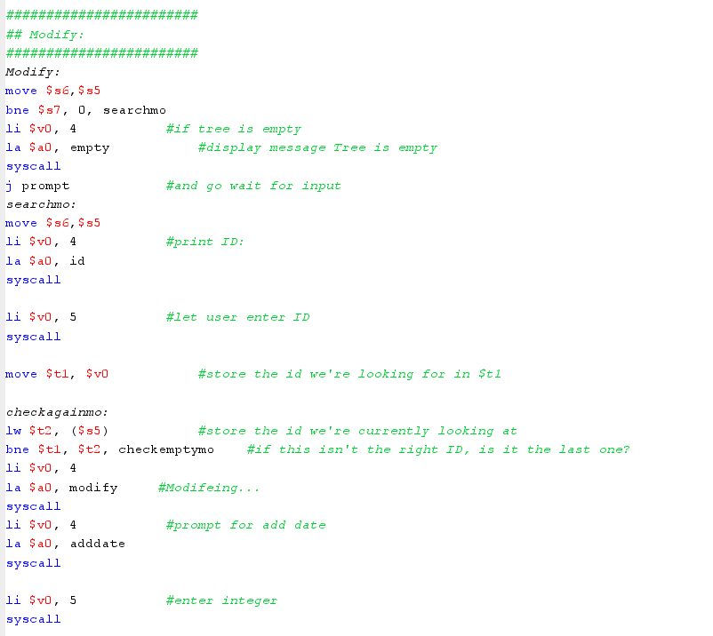
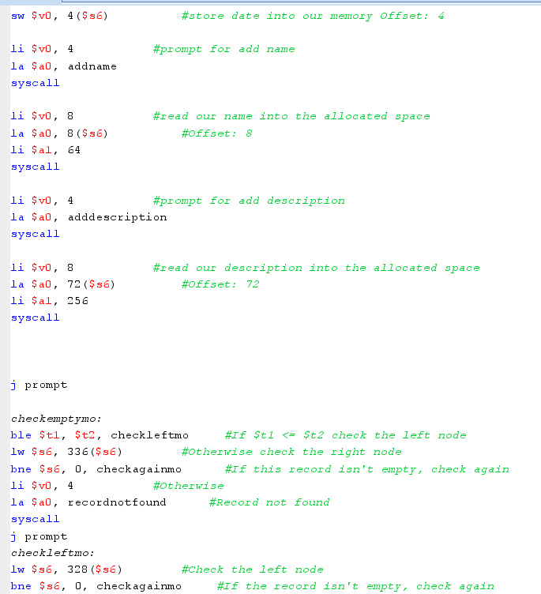
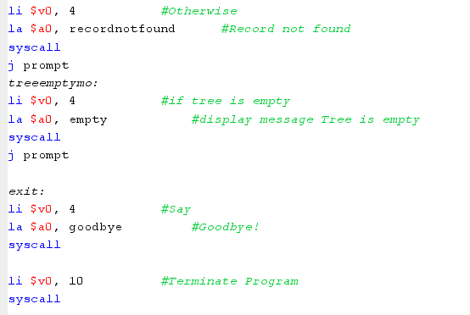

- Modify: This is a label indicating the beginning of the modification section of the program.
- move $s6, $s5: This instruction moves the content of register $s5 into register$s6. This likely sets up $s6 to point to the root node of the tree.
- bne $s7, 0, searchmo: This instruction branches to the searchmo section if the value in register $s7 (which likely stores the size of the tree) is not equal to zero. It checks if the tree is empty.
- li $v0, 4: This loads the system call code for printing a string into register $v0.
- la $a0, empty: This loads the address of the string "Tree is empty" into register $a0.
- syscall: This executes the system call to print the message "Tree is empty".
- j prompt: This unconditional jump instruction redirects the program flow back to the prompt section, effectively restarting the program loop.
- searchmo: This is a label indicating the beginning of the search section of the program.
- move $s6, $s5: This instruction again moves the content of register $s5 into register $s6, likely resetting $s6 to point to the root node of the tree.
- li $v0, 4: This loads the system call code for printing a string into register $v0.
- la $a0, id: This loads the address of the string "ID: " into register $a0.
- syscall: This executes the system call to print the message "ID: ".
- li $v0, 5: This loads the system call code for reading an integer from input into register $v0.
- syscall: This executes the system call to read an integer from input, likely representing the ID of the record to be modified.
- move $t1, $v0: This moves the integer read from input (the ID) into register $t1. checkagainmo: This is a label indicating the start of a loop to check each record in the tree for the matching ID.
- lw $t2, ($s5): This loads the ID of the current record being examined into register $t2.
- bne $t1, $t2, checkemptymo: This instruction branches to the checkemptymo section if the ID in register $t1 (the user-provided ID) is not equal to the ID in register $t2 (the ID of the current record being examined).
- li $v0, 4: This loads the system call code for printing a string into register $v0.
- la $a0, modify: This loads the address of the string "Modifying..." into register $a0.
- syscall: This executes the system call to print the message "Modifying...", indicating that the modification process has started.
- li $v0, 4: This loads the system call code for printing a string into register $v0.
- la $a0, adddate: This loads the address of the string "Enter the date: " into register $a0.
- syscall: This executes the system call to print the prompt for the user to enter the new date.
- li $v0, 5: This loads the system call code for reading an integer from input into register $v0.
- syscall: This executes the system call to read an integer from input, which is likely the new date for the record.
- sw $v0, 4($s6): This stores the integer read from input (the new date) into the memory location pointed to by register $s6 with an offset of 4 bytes. This likely updates the date field of the record being modified.
- The next few lines (li $v0, 4, la $a0, addname, syscall, li $v0, 8, la $a0, 8($s6), li $a1, 64, syscall) follow a similar pattern, prompting the user to enter the new name for the record and updating the corresponding field in the record.
- Similarly, the subsequent lines prompt the user to enter the new description for the record and update the corresponding field in the record.
- j prompt: This unconditional jump instruction redirects the program flow back to the prompt section, effectively restarting the program loop after the modification process is completed.
- The final segment of the code:

- The rest of the code primarily handles various scenarios related to searching for a record with a specified ID in a binary search tree (BST) and provides appropriate responses based on the outcome.

- In the checkemptymo and checkleftmo sections, if the subtree being checked is not empty, the program continues its search for the record by jumping back to the checkagainmo section. However, if the subtree is empty, indicating that the record is not present, the program prints a "Record not found" message and redirects the program flow back to the prompt section for further user interaction.

- The treeemptymo section manages an empty tree situation, displaying a message indicating such and returning it to the prompt section.

- Eventually, the exit section signifies the program's end, displaying a "Goodbye!" message and terminating program execution.

Running code:
Step 1:

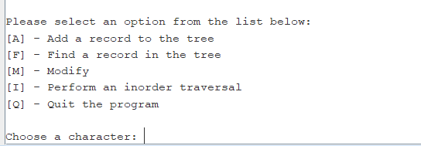

Step 2~8: add a record to the tree.

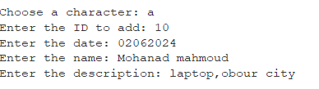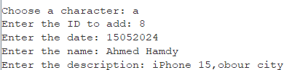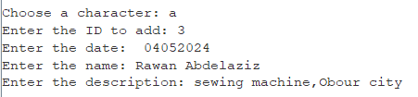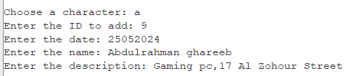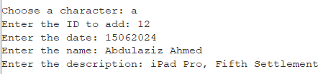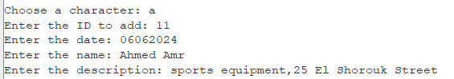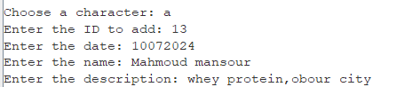

Step 9: search for wrong ID

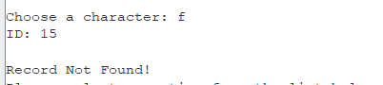

Step 10: find ID 10

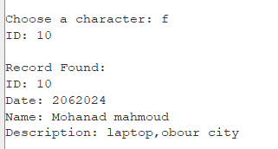

Step11: In-order

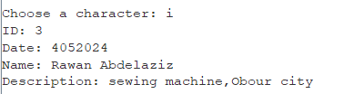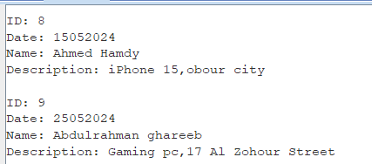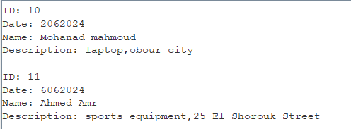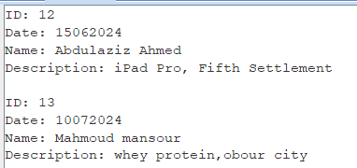

Step 12: modify.
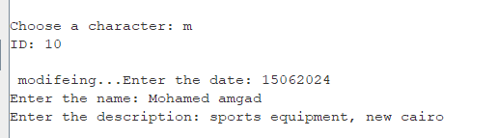

Step 13: find ID 10

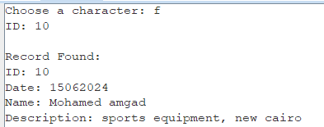

Step 14: exit

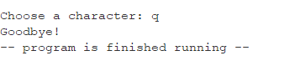

Conclusion:

The MIPS assembly language implementation presented here offers a functional binary search tree (BST) management system. Through a series of user prompts and input processing, users can interactively add, find, modify, and traverse records within the BST.

Overall, this MIPS assembly language implementation offers a robust foundation for managing records in a binary search tree. Its user-friendly interface and comprehensive functionality make it suitable for basic record management tasks, providing a versatile tool for data organization and retrieval. Further enhancements could include additional operations such as deletion of records, balancing of the BST, or graphical visualization of the tree structure.

- Reference:

- Schoolbook data_structures_and_algorithms_in_java.pdf
- ComputerOrganizationAndDesign5thEdition2014.pdf
- Stack Overflow - Where Developers Learn, Share, & Build Careers
- GeeksforGeeks | A computer science portal for geeks

the tasks performed.

Name | percentage each task
Abdulrahman Ghareeb AbdulSattar Muhammad | Code:16.67%  Report: 16.67%  Presentation: 16.67%
Ahmed Hamdi AbdulSattar Jadallah | Code:16.67%  Report: 16.67%  Presentation: 16.67%
Ahmed Amr Ahmed Hashem | Code:16.67%  Report: 16.67%  Presentation: 16.67%
Abdulaziz Ahmed Abdulaziz Abdulnabi | Code:16.67%  Report: 16.67%  Presentation: 16.67%
Muhannad Mahmoud AbdulWahab Ahmed | Code:16.67%  Report: 16.67%  Presentation: 16.67%
Rawan Abdulaziz Ali Abdulaziz | Code:16.67%  Report: 16.67%  Presentation: 16.67%

